**NAME**

**REG NUMBER**

**Data analysis:**

I**ntroduction**

This data and report is based on the dataset from the residents of Kansas City. Based on the data-set, the researcher intends to find out some of the incoming request and be able to group and categorise these requests accordingly.

**Data description**

From a manual analysis of the dataset, the fowling can be established for the dataset

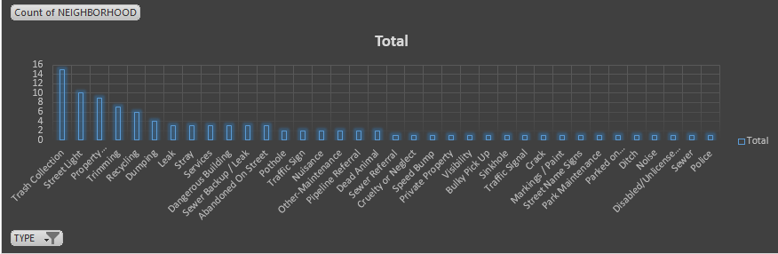

That trash collection is the leading cause of request in the neighbourhoods with up to 18 request per day. Followed by Street light issues and then Property and trimming. At the bottom as least requested are noise and sewer related issues.

When it comes to incoming requests per neighbourhood. Shoal creek was leading in the number of incoming requests and complaints followed by Mount Hope and then Little Blue Neighbourhood. A further look and study of the socio economic status of Shoal creek for example revealed that it’s a very disorderly state. This is due to the fact that the state has rampant black outs out a maximum of 5 recorded cases, there are also recorded cases of physical abuse , injury and even in most cases death related incidents. The neighbourhood is also dirty and has unfixed issue of trash collection and management

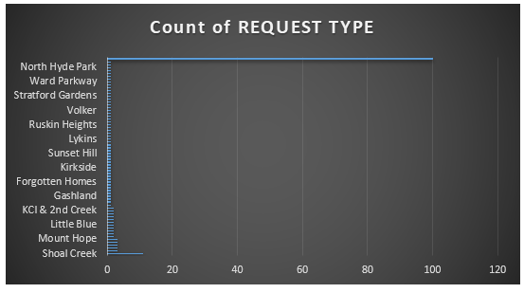

In conclusion therefore, we can say that the government of Kansas needs to step up its efforts in managing the issues being raised by the community participants at every neighbourhood. The analysis done in these states can help highlight some of the issues.